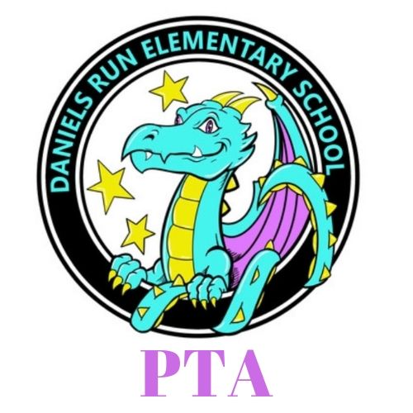
Daniels Run PTA
Meeting Minutes- October 13, 2021

I. Welcome and Introductions

II. Call Meeting to Order @ 7:03 pm

III. Admin Report - Mr. Smith-
Reading and Math and Social Emotional Assessments that are being given currently. We gave everyone a DRA, because we felt like it was a good measure for where kids are at. The Social Emotional screener is our last one to give.

After school activities went smoothly the first day was yesterday.

Thanksgiving lunch is not going to happen this year on Veteran’s Day

Covid messages this week- when it comes to notification, I am still notifying the community as soon as I know about the case and not once a week. The 14 day quarantine is still in place, so we are not allowed to change that. The health department says that if you stay the 14 days out the chances of you spreading it are way less than if you change that to a 10 day policy.

No test required to have test to return to school with symptoms
If they leave school with symptoms they do have to get a negative test

IV. Reports of Officers
- President- Lacey O’Donnell
  - Upcoming Events- dance a thon fundraiser- how to register your student
    - Movie night on saturday October 23rd, we will have free popcorn and will sell concessions
    - Another event in partnership with PES PTA and Parks and Rec on Oct 29th
    - Book fair is coming nov 8-12th, with a family event on the afternoon/evening of the 11th
  - Volunteers Needed-donations of carved pumpkins and your time for Oct. 29th van dyke event
    - Need help in clinic with vision and hearing tests- talk to school health aid
    - https://www.danielsrunpta.org/getinvolved
  - Thank Yous-
- VP Fundraising- Kara Custis
  - Dance-a-Thon- we’ve raised $3,400 which is 13% of our goal
    - Dance a thon is a 30 minute dance on friday oct 22nd- all classes will come and there will be contests and voting for our movie night
    - Spread the word and get the kids excited!!
  - Dining for Dollars - working on it- chipotle canceled our upcoming one, we are hoping to do one before the winter holidays
  - Spirit Wear Update- great turn out and give back to the school
- VP Membership- Maureen Szente
  - Membership Update- we currently have 214 members, 14 more than last month
  - PTA Meeting Drawing- winner of dunkin donuts gift card is Purvee Patel
    - We are hoping to do a grade level membership drive in november
- Secretary- Beth Brixius
  - Directory- We are working on building the directory and we will make sure to announce when it is complete and up and running
- Treasurer - Mariela Curet
  - Budget Update

V. Adjournment @ 7:28 PM
5th GRADE REPORT:
-POG - presentation of learning- communicator skills and collaborator

Sock-tober all month with counselor
https://www.signupgenius.com/go/10c0d45a9ad2aa6fb6-socktober

Last week of the month will be spirit wear week!

Future Dates

October 8-24 Fundraiser
October 13 PTA Meeting
October 18 Dine for Dollars at Chipotle- CANCELED
October 22 Dance-a-Thon
October 23 Outdoor Movie Night
October 29 Spooktacular Stroll
November 8-12 Book Fair
November 11 Book Fair Open to Families
November 18 PTA Meeting

