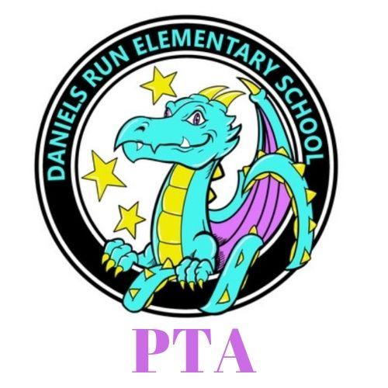
Daniels Run PTA
Meeting Minutes February 15, 2022

I. Welcome and Introductions

II. Call Meeting to Order @ 7:03 pm

III. Admin Report - Mr. Smith
Thanks to the PTA for the Ice Skating Event, and the staff treats delivered yesterday. Thank you for support from families during the winter weather. Last week was the State of Schools presentation for the City of Fairfax Schools. I'm glad to work in this community and glad to work here with everyone.
Kindergarten Orientation- we are doing KP3 again this year for 2022-2023 SY. Teachers gather more info from the students.
Read Across America Day- March 11th- we get a great turn out of community Members
Summer programs- July 11-29, Bridge to K, Young Scholars
Calendar for next year is out- 1st day of school is August 22nd
IV. Staff Report - ESOL Team- Ms. Pougiales presenting
Updates: 220 students in our program. We work primarily in small groups within our domains. We work content into what we are working with them on. We work on inferring, describing, comparing and contrasting. We love that we have a diverse community, with 21 documented languages on file in our community. We have lots of staff members that can help us bridge with these students. The majority of our ESOL students are Spanish speakers. We are at the tail end of our WETA testing that goes on for over a month in February. There are 4 parts to the test. We are lucky to work with these students and their families.

V. Reports of Officers
- President- Lacey O’Donnell
  - Ice Skating Event Report- great event 114 students attended, great cross section of people who attended, would love to make it annual!
  - Grants Update-we are awarding them to staff, the monthly newsletter highlights those grants and there is still grant money still available, we love funding these grants
  - 2’s Day- coming up on Tuesday 2/22/22- Spirit Day, wear tye-dye and consider doing two acts of kindness, we will pass them out as students arrive - we are encouraging the kindness component
  - Nominating Committee- we are nearing the need for a committee to select the next board, those people present a slate of people in April to be voted on in May.
- VP Fundraising- Kara Custis
  - Dining for Dollars
      - Flippin Pizza- sunday 2/19 4pm
      - Choobalah march 4-9pm
- VP Membership- Maureen Szente
  - Membership Update- since 1/10 we’ve had 15 new members join, a contest for new members ends on March 1st- the winner will win a $25 grocery gift card. We have 245 total members
  - Winter Membership contest
- Secretary- Beth Brixius
  - School of Excellence- we are working to implement a plan to support the arts and grow our school and family engagement and partnerships.
- Treasurer
  - Budget Report- we are on budget and working to still learn the books as we had a transfer of power mid year.

VII. Adjournment @ 7:25pm

Future Dates

February 20th Dine for Dollars at Flippin Pizza
February 22nd 2’s Day

