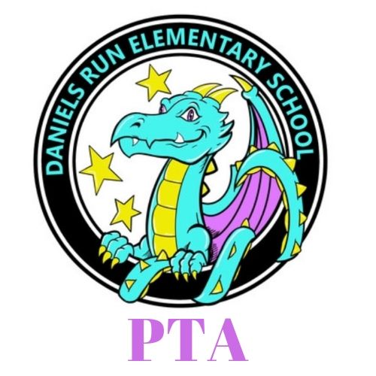
Daniels Run PTA
Meeting Minutes September 14, 2021

I. Welcome and Introductions

II. Call Meeting to Order @ 7:03 pm

III. Admin Report - Mr. Smith
A.update- Thanks to the PTA, opening week lunch before welcome walk, and Lacey for joining the news, and stuffing the staff lounge and back to school picnic

B. returning 760 students has been successful- great to hear and see the kids back in person. Our enrollment is excellent this year
Staff-fully staffed except for from office to replace Araceli(SIA/registrar)
Morning meeting is built in and last friday our mega morning meeting was great
We are currently assessing them on current level of academics
Email coming from me 9/20 about what we are planning to do
Kids are following directions really well with masking
Challenges- dismissal and transportation, we were close to getting kids out of classrooms by 4pm
The buses are at multiple schools before and after us so it is not a perfect system yet but it could be worse
Lunch- masks are off, but we are hoping for a sustainable lunch plan, need a plan inside for when weather is bad
5 filters were donated to the cafeteria, nothing is wrong with the cafeteria but it is extra
We may make adjustments for the lunch schedule
Experimented with lunch in the courtyard and it worked well, we have asked for additional staff for lunch monitors
Upcoming events= plan to start activities afterschool on oct5 with late buses two days a week
It may be delayed into october and buses available for those activities
First session oct 5-nov 18th, jan-march, final session after spring break
Run by staff

IV. Reports of Officers
- President- Lacey O’Donnell
  - Back to School Kick Off
    - Teacher Appreciation-gave out dragon tattoos to students and staff
    - Back to School Night Picnic- wonderful community event, we are looking forward to your feedback!It was a busy and exciting night
  - Volunteers Needed
    - All kinds of ways to volunteer
    - Stuffing flyers
    - Visit the pta website
    - Fcps mentoring
    - Library helper for Ms Gavin, needs help from parent volunteers

  - Upcoming Events- outdoor movie night, book fair as well- events evolve as the rules with covid evolve
  - Thank Yous- thank the audit committee - eva Martin, Julie Tuesta, our web designer Jessi Katz- Kindergarten parent kristina pritchard helped with the picnic last night
- VP Fundraising- Kara Custis
  - Spirit Wear- online store ends 9/15- we’ve raised $5K in sales
  - Dining for Dollars - panera tonight! Next is Chipotle Oct 18th
  - Future Fundraising- happening mid-october- Dance a thon- raising money for the arts at our school- murals, beautification, materials for art, instruments, band and strings, author and artist visits and assemblies
  - Movie night in october with the fundraiser
- VP Membership- Maureen Szente
  - Joining the PTA- Membership Contest- all member raffle $25 to buy spirit wear items, we are also doing classroom contests- the class with the most members gets popsicles and spiritwear for their teachers
  - Raffle during this meeting for people who came to see us tonight- teal childrens t shirts - Jen Brown was our winner tonight-congrats!
  - Membership Update- 200 members in the PTA
- Secretary- Beth Brixius
  - Directory- will be coming out by october 1st and will be for members only
- Treasurer - Mariela Curet
  - Audit - committee approved last years books
  - New Budget - we will be voting on the new budget tonight
  - This budget is ambitiously following past years before covid and includes events we will be able to do as the rules surrounding covid change and adapt throughout the year

VI. New Business 35 members in attendance tonight for quorum
- 2020-2021 Audit Approval- approved
- 2021-2022 Budget Approval- approved

VII. Adjournment @ 7:32pm

Future Dates

October 13 PTA Meeting
October 18 Dine for Dollars at Chipotle
November 18 PTA Meeting

